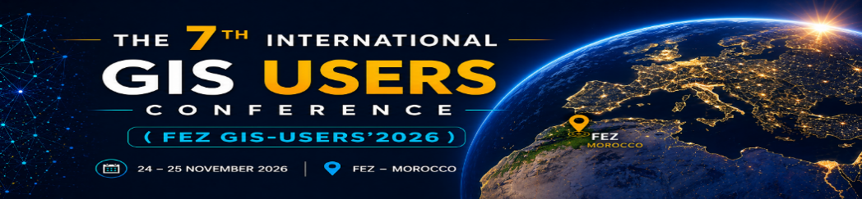
Presentation of the GIS-USERS’2026 Conference

The 7th International Conference of GIS Users (FEZ GIS-Users’2026)

Conferences - Communications - Workshops
Fez, Morocco | November 24 - 25, 2026

Registration Type:  Communication (abstract submission)/ Workshops/ Attendance  Type d’Inscription :  Communication (Soumission des résumés) / ateliers / Présence | Notification of Acceptance  of communication  Notification d'acceptation  de la communication  July 25, 2026  25 Juillet 2026 | Submission of  Extended Abstract  Soumission du  Résumé Étendu  September 10, 2026  10 September 2026 | Prepayment deadline  (Bank transfer)  Délai de paiement anticipé  (Transfert bancaire)  October 1, 2026  1 October 2026

Main Research Themes






Thématiques Principales

Geographic Information Systems and Spatial Web Technologies

Geo-Artificial Intelligence and Advanced Spatial Data Science
Geomatics for Natural Hazards and Disaster Risk Management
Climate Change, Spatial Planning and Sustainable Urban Systems
Remote Sensing, Photogrammetry and GPS Applications
GIS for Sustainable Territorial Management and Resource Governance



Keynote Speakers
Conférenciers d'Honneur

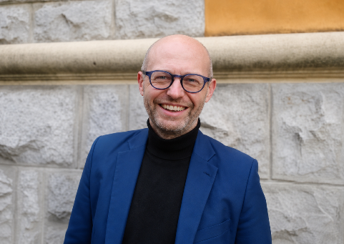
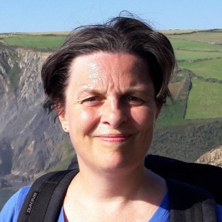
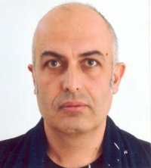

Pr. Richard T. WALKER
Department of Earth Sciences, University of Oxford, United Kingdom
Pr. Ali BULBUL
Pamukkale University, Denizli, Türkiye
Pr. Anne GOBIN
KU Leuven University, Belgium


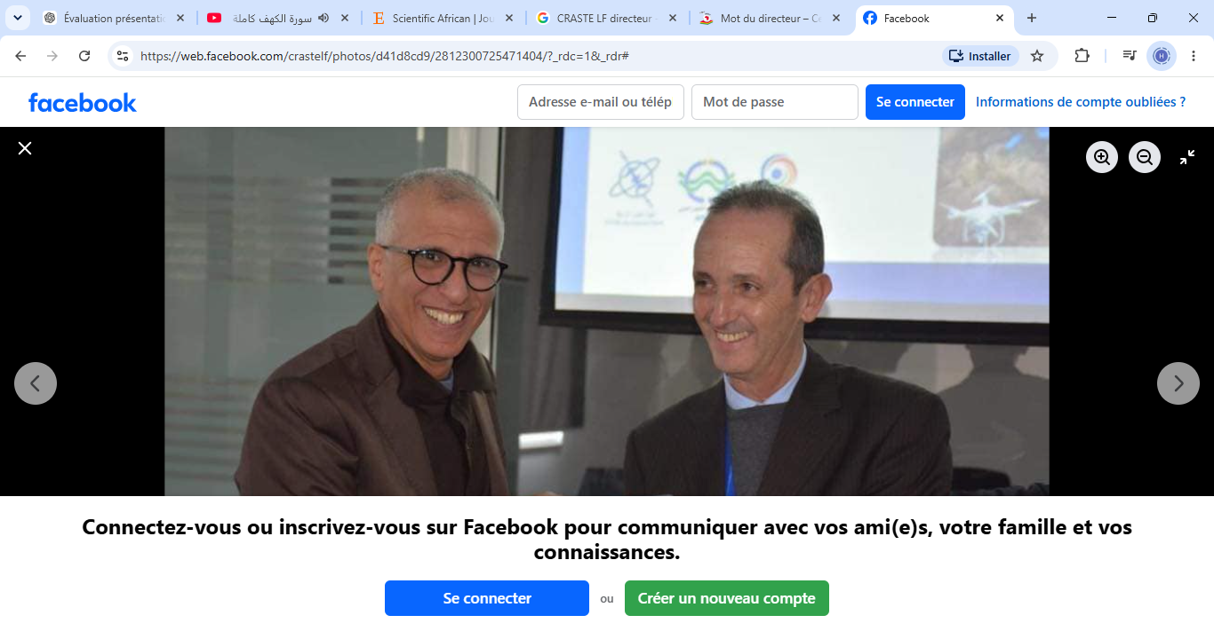

Pr. Abdelghani BOUDHER
Faculty of Sciences and Techniques, Cadi Ayyad University, Marrakech, Morocco
Pr. Anas EMRAN
Director of the African Regional Center for Space Science and Technology in the French Language in Rabat, Morocco

Committees / Comités

Honorary Committee/ Comité d'Honneur
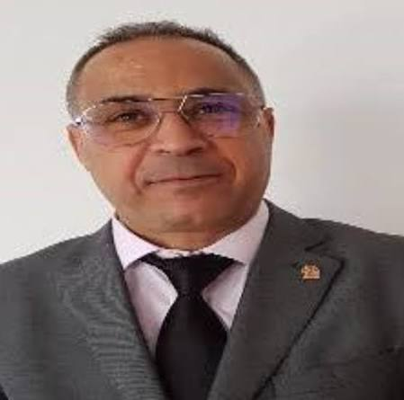
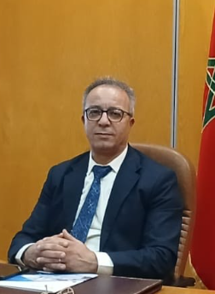
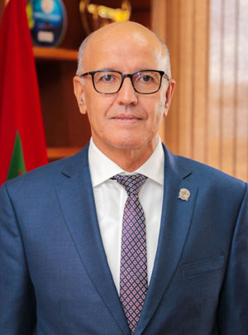
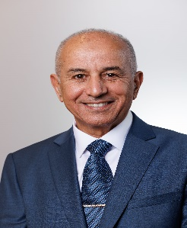
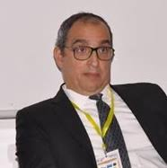

President USMBA
Pr. Mustapha IJJAALI
Deputy Director ENS FEZ

Pr. Saâd BENNANI DOSSE
Dean FSDM Fez
Pr. Mohammed BELKASMI

Director ENSA Fez
Pr. Abderrahim LAHRACH
Director ENS Fez
Pr. Ali AHAITOUF

HONORARY COMMITTEE OF COORDINATORS OF PREVIOUS EDITIONS/ Comité d'Honneur DES COORDINATEURS DES ÉDITIONS PRECEDENTES

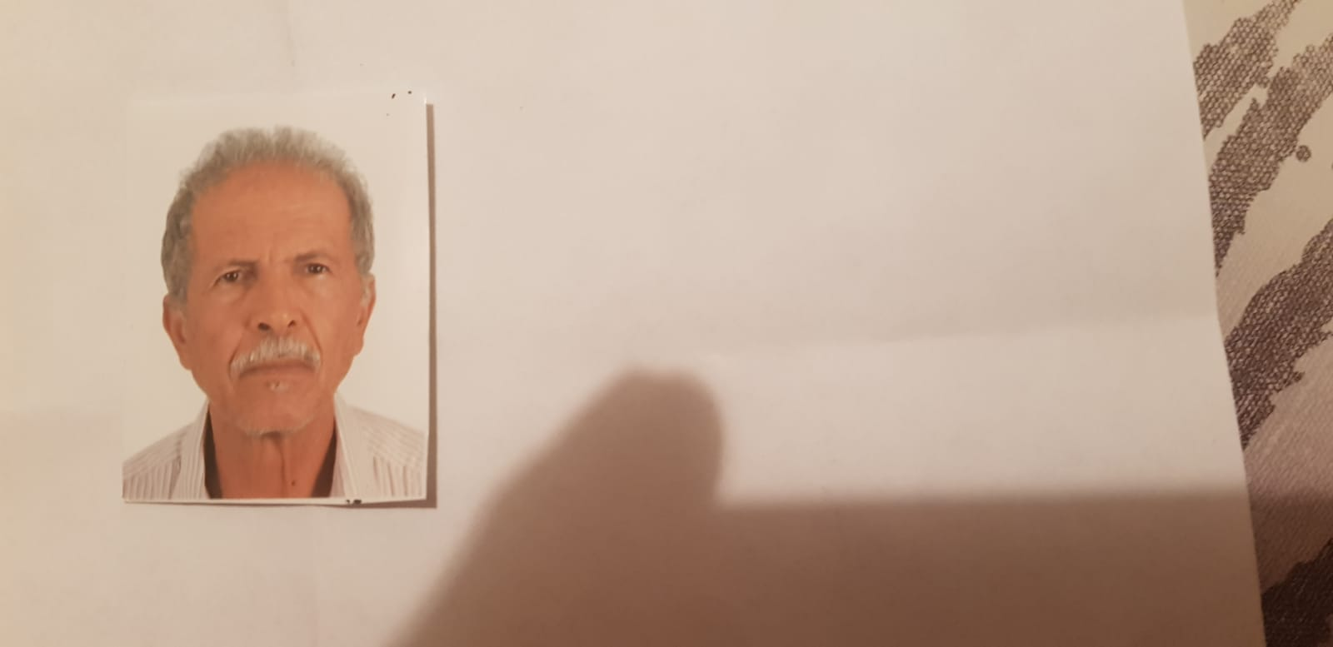
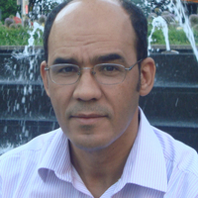
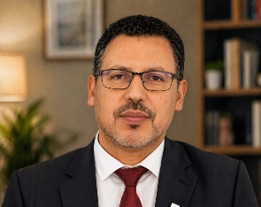

PROFESSOR FLSH OUJDA
and
coordinator, 3rd edition GIS USERS’ 2016, OUJDA
Pr. Abdelkader SBAI
DIRECTOR EST KHENIFRA
and
coordinator, 2nd edition of the GIS USERS’ 2014, MEKNES
Pr. Ali ESSAHLAOUI
Dean FP TAZA
and
coordinator, 1st edition of the GIS USERS’ 2012, Taza
Pr. Hassan TABYAOUI

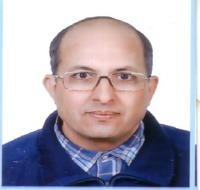
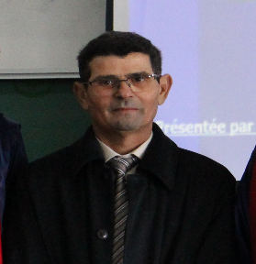
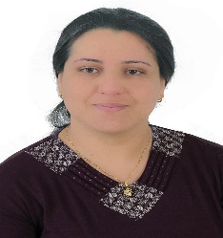

PROFESSOR FST ERRACHIDIA
and
coordinator, 6th edition of the GIS USERS’ 2024, ERRACHIDIA
Pr. Amina KASSOU
PROFESSOR FS MEKNES
and
coordinator, 4th edition of the GIS USERS’ 2018, MEKNES
Pr. Elmostafa MILI

PROFESSOR FLDM FEZ
and
coordinator, 5th edition of the GIS USERS’ 2023, FES
Pr. Bouchta El KHAZZAN

Pr. Hicham BENBAQQAL

International Scientific Committee / Comité Scientifique International
Dr. Achibane Hassan (ANEF / Ifrane)  Pr. Anton Van Rompaey (Univ. KU Luven, Belgique)  Pr. Ahmed Mohamed Saqr (Univ. Mansoura, Egypte)  Dr. Alitane Abdennabi (UM6 / Ben Guerir)  Pr. Amine Afaf (FS, UM5 / Rabat)  Pr. Azyat Abdelilah (ENSA, UAE / Tanger)  Pr. Belmahi Mohamed (ENS, UM5 / Rabat)  Pr. Benamar Saad (ENS, USMBA / Fès)  Pr. Benamara Ahmed (ENSAM, UMI / Meknès)  Pr. Ben Abbou Soumaya (ENSAM, UMI / Meknès)  Pr. Ben Achab Nizar (ENSA, UAE / Tanger)  Pr. Benbaqqal Hicham (ENS, USMBA / Fès)  Pr. Benyassine El Mehdi (INSAP, Rabat)  Pr. Benzoughar Brahim (IS, UM5 / Rabat)  Pr. Bouchaou Lhoussaine (FS, UIZ / Agadir)  Pr. Boudher Abdelghani (FST, UCA / Marrakech)  Dr. Bourhzali Mohammed (FLDM, USMBA / Fès)  Pr. Deffontaines Benoit (Univ. G. Eiffel, Paris-Est / France)  Pr. Elaloui Abdenabi (FST, USMS / Béni Mellal)  Pr. El Aroussi Omar (FLSHJ, UCD / El Jadida)  Pr. El Asmi Hicham (ENS, USMBA / Fès)  Pr. El Hafyani Mohammed (FS, UIZ, Agadir)  Pr. El Hamdouny Malika (FLDM, USMBA / Fès)  Pr. El Khazzan Bouchta (FLDM, USMBA / Fès)  Dr. Elkourchia Abdelfettah (EST, USMS, Fkih Ben Salah)  Pr. El Kharki Omar (FST, Tanger)  Pr. El Myr Ali (ENS, USMBA / Fès)  Pr. EL Monhim Bilal (ENS, USMBA / Fès)  Pr. El Ouali Abdelhadi (FS, UMI / Meknès) | Pr. Emran Anas (CRAST-LF / Rabat)  Pr. Erraji Ahmed (Ex. Cadre du CRTS, ADN, Rabat)  Pr. Essahale Adil (ENS, USMBA / Fès)  Pr. Essalek Bouchaibe (FSE, UM5/ Rabat)  Pr. Essahlaoui Ali (EST, USMS / Khénifra)  Pr. Erragragui Mohamed (FST, UCA / Marrakech)  Pr. Gobin Anne (Univ. KU Luven, Belgique)  Pr. Hamdach Youssef (FLSHJ, UCD / El Jadida)  Pr. Karaoui Ismail (FST, USMS / Béni Mellal)  Pr. Kassou Amina (FST, UMI / Errachidia)  Pr. Laaribya Said (FSHS, UIT / Kénitra)  Pr. Laguenini Fouzia (ENS, USMBA / Fès)  Pr. Lamhasni Taibi (INSAP, Rabat)  Pr. Lhachmi Ali (FP, USMBA / Taza)  Pr. Louaya Abdelkarim (FSDM, USMBA / Fès)  Pr. Masrour Aissa (FS, UMI / Meknès)  Pr. Mdiker Nabil (FS, UM5 / Rabat)  Pr. Midaoui Abdelbaset (FLDM, USMBA / Fès)  Pr. Mili El-Mostafa (FS, UMI / Meknès)  Pr. Raissouni Naoufal (ENSA, Tétouan)  Pr. Rajhi Hayfa (Univ. Gabbes / Tunisie)  Pr. Redouane Meryem (FSDM, Fès)  Pr. Rudan Jean-Paul (Univ. G. Eiffel, Paris-Est / France)  Pr. Sallah Amine (ENS, USMBA / Fès)  Pr. Slali Hamid (ENS, USMBA / Fès)  Pr. Souab Majda (FLDM, USMBA / Fès)  Pr. Zakaria Othmane (ENS, USMBA / Fès)  Pr. Zouhri Driss (FLDM, USMBA / Fès)

Organizing Committee / Comité d’Organisation

Professors/ Professeurs
Pr. Belmahi Mohamed (ENS, UM5 / Rabat)  Pr. Baslam Abdelmounaim (ENS, USMBA / Fès)  Pr. Benamar Saad (ENS, USMBA / Fès)  Pr. Benbaqqal Hicham (ENS, USMBA / Fès)  Pr. Ben Fares Samiha (ENS, USMBA / Fès)  Pr. Benyassine El Mehdi (INSAP, Rabat)  Dr. Bourhzali Mohammed (FLDM, USMBA / Fès)  Pr. El Asmi Hicham (ENS, USMBA / Fès)  Pr. El Khattabi Khalid (ENS, USMBA / Fès)  Pr. El Myr Ali (ENS, USMBA / Fès)  Pr. Essahale Adil (ENS, USMBA / Fès) | Pr. Essahlaoui Ali (EST, USMS / Khénifra)  Pr. Laguenini Fouzia (ENS, USMBA / Fès)  Pr. Lamhasni Taibi (INSAP, Rabat)  Pr. Lamsaadi Nadia (ENS, USMBA / Fès)  Pr. Nouiga Abdesslam (CRMEF de Fès-Meknès)  Pr. Slali Hamid (ENS, USMBA / Fès)  Pr. Squalli Wafae (ENS, USMBA / Fès)  Pr. Zarrouq Btissame (ENS, USMBA / Fès)  Pr. Zakaria Othmane (ENS, USMBA / Fès)  Pr. Zouhri Driss (FLDM, USMBA / Fès)

PhD Students/ Doctorants

Bellatik Issame (ENS, Fès)  Boukarai Asmae (ENS, Fès)  Chamcham Mohammed (FLDM, Fès)  Cherkaouy Fadwa (ENS, Fès)  El Abedy Meryem (FLDM, Fès)  El-Ouali Salma (ENS, Fès)  Ettifouri Salma (ENS, Fès) | Fergougui Mohamed (FSDM, Fès)  Hilali Adil (FLDM, Fès)  Lamriss Abderrazzak (ENS, Fès)  Lyazidi Aziza (FSDM, Fès)  Mardi Souhaila (FLDM, Fès)  Masrar Mohamed (ENS, Fès)  Moubtassim Youssef (FLDM, Fès)

Overview of GIS USERS and Scientific Scope
Aperçu et Portée Scientifique
Geographic Information Systems (GIS) currently occupy a strategic position in the analysis, management, and valorization of spatial data. They provide advanced tools that help understand the complexity of territorial dynamics and support decision-making processes. In a context characterized by climate change, accelerated urbanization, and increasing pressure on natural resources, GIS represents a key instrument for sustainable territorial governance. In Morocco, the use of GIS has experienced significant expansion across public, semi-public, and private sectors.
Within this context, the International GIS Users Conference (FEZ GIS-Users’2026) has emerged as a scientific and technical platform dedicated to the promotion and dissemination of advances in geomatics. Since its first edition held in 2012 at the Faculty of Multidisciplinary Studies of Taza, followed by subsequent editions in Meknes (2014), Oujda (2016), Meknes (2018), Fez (2023) after an interruption caused by the COVID-19 pandemic, and Errachidia (2024), this event has contributed to building a dynamic national community that remains strongly open to international collaborations.
The conference aims to promote innovation in emerging fields such as remote sensing, spatial modeling, Geo-Artificial Intelligence (Geo-AI), and geospatial Big Data. It also encourages interdisciplinarity and fosters interactions among researchers, decision-makers, and socio-economic stakeholders. Thus, the GIS-USERS Conference serves as a strategic framework for skills development, knowledge transfer, and the implementation of innovative solutions addressing current and future challenges of sustainable development.

Registration Fees / Frais de participation
GIS USERS ConFERENCE 2026

Category | Before October 1, 2026 | After October 1, 2026
Moroccan PhD Student | 400.00 MAD | 600.00 MAD
International PhD Student | 800.00 MAD (80 Euro) | 1000.00 MAD (100 Euro)
Moroccan Faculty Member / Researcher | 800.00 MAD | 1000.00 MAD
International Faculty Member / Researcher | 1000.00 MAD (100 Euro) | 1200.00 MAD (120 Euro)
Participants from Public Governmental  or Independent Institutions | 1000.00 MAD (100 Euro) | 1200.00 MAD (120 Euro)

10. Registration and Abstract Submission
Registration and abstract submission are conducted exclusively through the conference Google Forms link: https://forms.gle/JVRMeFaosiazfFpL6

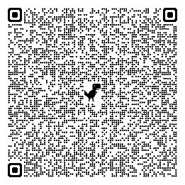
Conference Venue: Conference Center USMBA, Fez, Morocco
https://maps.app.goo.gl/AkrFEko1ef5KyzQSA?g_st=awb

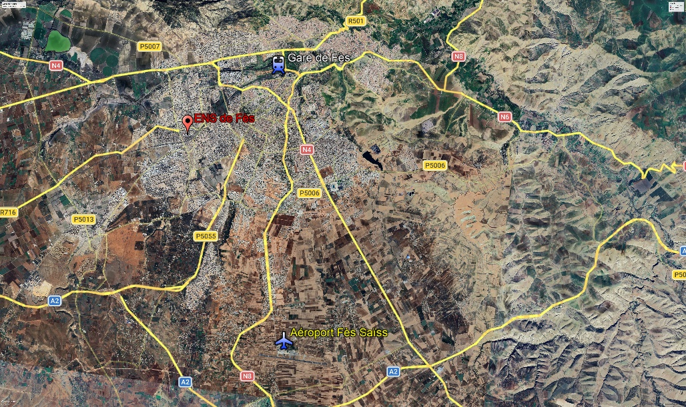
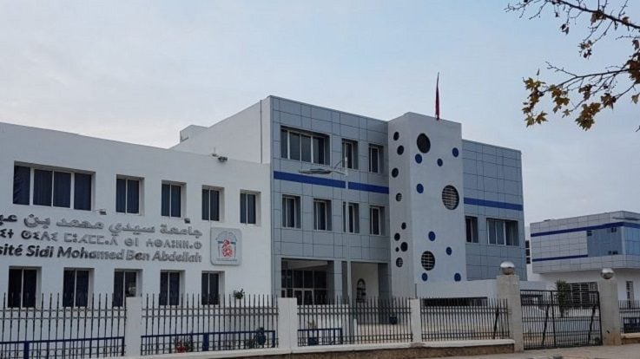
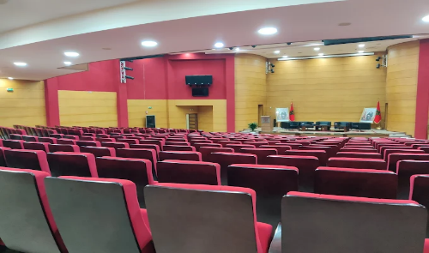
GPS Infographics

